FOR IMMEDIATE RELEASE

Press Contact: Bianca Martucci-Fink
The Trout Gallery, Dickinson College
717–254– 8159
martuccb@dickinson.edu

ART EXHIBITION “HORACE PIPPIN: RACISM AND WAR”
OPENS AT THE TROUT GALLERY, DICKINSON COLLEGE

Exhibition of WW I and WWII art focuses on how racism
undermines the nation’s efforts abroad and at home

CARLISLE, Pennsylvania—September 24, 2021—The Trout Gallery, Dickinson College, opens art exhibition Horace Pippin: Racism and War. Exhibition addresses the threat of systematic racism in the United States during World War I and World War II and its threat to the war effort abroad and at home. This exhibition focuses on a major painting by African American artist Horace Pippin, entitled Mr. Prejudice, which he painted in 1943. The painting features a prominent image of the letter V, a symbol of victory, and how the concept service, self-sacrifice, and unity was promoted among African Americans. The painting of Mr. Prejudice is shown in conjunction with World War I and World War II posters, the artist’s illustrated memoir, photographs, and other historic material items. This exhibition runs from September 24, 2021 to February 19, 2022. It is free and open to the public, Monday through Saturdays, 10a.m. to 4p.m., and Thursdays until 8pm.

Phillip Earenfight, Director of The Trout Gallery, notes, “This is a major painting by a major artist of a central issue in this country at a pivotal moment in time. It comes to The Trout Gallery at a crucial point in this country’s history; a moment when division over matters of race have returned to frightening, self-destructive levels. The painting’s message that racism divides us and threatens our society and the highest of our priorities is as pointed and relevant today as it was the day Pippin finished it. We need this painting now.”

Horace Pippin: Racism and War centers on Horace Pippin’s painting Mr. Prejudice (1943), which the artist created during the height of World War II. The painting portrays an allegorical figure of Mr. Prejudice driving a wedge into a large “V”-ictory, illustrating how racism divides American society and efforts to win the war. The figure of Mr. Prejudice occupies the central axis of the composition and hammers a wedge into an oversize V. Flanking Mr. Prejudice are Lady Liberty, a Ku Klux Klansman, and a White man holding a noose. Crowded below are Black and White defense workers, Black and White servicemen—including a medic—outfitted for World War II, and a Black doughboy from World War I. Pippin positioned the V’s fracture at the painting’s geometric center and bisected the composition horizontally to divide the allegorical figures above from the human beings below. The painting’s sharp compositional breaks highlight the theme of division and separation.

Mr. Prejudice is presented in the exhibition among a number of World War I and World War II posters that highlight the role of African Americans in the service of the country. Several illustrate Black soldiers leaving hearth and home to fight abroad; others illustrate the heroism and sacrifice of specific Black
servicemen in support of the war effort. These posters are complemented by others that feature
V-ictory images from World War II. They define the image of the V as a symbol of democracy and Allied unity that was to be used widely throughout much of World War II.

The exhibition also features a number of photographs and artifacts associated with an African American initiative known as the Double-V, which aimed to expand on the single V concept of victory abroad, with a double victory—abroad and at home. The materials show how many African Americans questioned U.S. efforts to preserve democracy in Europe when it had yet to be fully implemented at home. The Double-V campaign was spearheaded by a letter written on January 31, 1942 to the Pittsburgh Courier, by James G. Thompson, who proposed: “I suggest that while we keep defense and victory in the forefront that we don’t lose sight of our fight for true democracy at home. The V for victory sign is being displayed prominently in all so-called democratic countries which are fighting for victory over aggression, slavery and tyranny. If this V signs means that to those now engaged in this great conflict then let we colored Americans adopt the double VV for a double victory. The first V for victory over our enemies from without, the second V for victory over our enemies from within. For surely those who perpetrate these ugly prejudices here are seeking to destroy our democratic form of government just as surely as the Axis forces.” The Double-V campaign was promoted by the editors at the Pittsburgh Courier, the nation’s most widely circulated Black newspaper and documented by its photographer Charles “Teenie” Harris, whose important photographs anchor this part of the exhibition.

This exhibition brings the Double-V campaign into contemporary light through the display of three volumes from the Marvel Comics series, Truth: Red, White and Black, which features the fictional character Isaiah Bradley brandishing the Double-V symbol as a Black superhero. Bradley figures in the recent the live-action Marvel Cinematic Universe television miniseries The Falcon and Winter Soldier.

Mr. Prejudice is on loan to The Trout Gallery as part of an American Art collections sharing initiative created through a multiyear, multi-institutional partnership formed by the Philadelphia Museum of Art as part of the Art Bridges Initiative. Earenfight adds: “Hosting this painting and mounting this exhibition represents a key moment in the history of the museum. On behalf of Dickinson College and the Carlisle community, I am deeply grateful to my colleagues at the Philadelphia Museum of Art and the Art Bridges Foundation, for their foresight, collegiality, and generosity to make the loan of such an important work at this time.”

Mr. Prejudice appears in conjunction with one volume of Pippin’s hand-written memoirs, which he wrote shortly after the end of World War I. This volume features a number of full-page color pencil drawings, which illustrate aspects of his experiences in battle. This remarkable memoir is on loan from the Smithsonian Institution Archives of American Art.

Horace Pippin (February 22, 1888 – July 6, 1946) was born in West Chester, Pennsylvania, Pippin, spent his childhood in Goshen, New York, before returning to West Chester as an adult. Pippin fought in World War I as part of the 369th Regiment (an African American Infantry division nicknamed the "Harlem Hell Fighters"). He was shot in the shoulder by a German sniper, which reduced the range of motion in his right arm for the rest of his life. About his combat experience, Pippin remarked: “I did not care what or where I went. I asked God to help me, and he did so. And that is the way I came through that terrible and Hellish place. For the whole entire battlefield was hell, so it was no place for any human being to be.” Pippin knew well how badly African American soldiers were treated by their fellow White American solders abroad and by their fellow Americans at home. After his return to the United States he began painting, a practice he had started as a young boy. His paintings represent portraits, landscapes, biblical subjects, domestic scenes, and events in World War I. Entirely self-taught, Pippin’s direct and forceful style combined with often folksy subject matter immediately attracted dealers, as well as curators from major museums, including the Museum of Modern Art, and collectors, such as Albert C. Barnes, who responded to the Modernist aspects of his work. He was the first Black artist to be the subject of a major monographic study and remains one of the leading artists of the century.
The exhibition will be explored by members of the Carlisle and Dickinson College community extensively through free panels, lectures, and programs offered by the museum’s education program. A number of these offerings will center on the experiences, perspectives, and voices of members of Carlisle’s African American community, past and present—particularly those who are associated with the various branches of the US military. According to Heather Flaherty, the museum’s curator of education: “We are collaborating with partners across the community, including Hope Station, the YWCA, the Cumberland. County Historical Society and Carlisle Arts Learning Center (CALC) to learn about African American experience in Carlisle, past and present, and to create collaborative works of art that powerfully showcase the stories and experiences we learn about in order to raise awareness of Carlisle’s Black history and encourage community dialogue about race. The generous grants provided by the Art Bridges foundation for these exhibitions have allowed us to expand our programming into the community in ways we never have before.”
Exhibition Credits:
This is one in a series of American art exhibitions created through a multi-year, multi-institutional partnership formed by the Philadelphia Museum of Art as part of the Art Bridges Initiative.

Publications:
Exhibition brochure with text by Anne Monahan: http://www.troutgallery.org/files/exhibitions/Pippin%20Brochure.pdf

Public Events (more to follow):
Opening Reception: Friday, September 24, 5–7p.m.
Family Night: Thursday, November 18, 4–7p.m.
Panel Discussion: December 2, 2021, 7 p.m.
Retired US Army Col. Gary Steele Lecture: February, 3, 2022, 7 p.m.

Museum Information:
The Trout Gallery is the art museum of Dickinson College. It is always free and open to the public. It is located in the Emil R. Weiss Center for the Arts at 240 West High Street, Carlisle, Pennsylvania, 17013.
The mission of The Trout Gallery is to inspire creativity and to support the study and experience of the visual arts through direct contact with works in the its collections and exhibitions. It serves the students, faculty and staff, and alumni of Dickinson College; the residents of the Carlisle-Central Pennsylvania area and their visitors; and the broader academic and artistic communities. It meets its objective through its collections, exhibitions, programs, publications, and professional resources.

###

Press Kit
http://www.troutgallery.org/exhibitions/detail/66

General inquiries: email trout@dickinson.edu / 717-245-1344

COVID-19 protocol updates and information, visit: http://www.troutgallery.org/about/2/

Updates from The Trout Gallery see: http://www.troutgallery.org.

Social media: @TroutGallery

EXHIBITION IMAGES
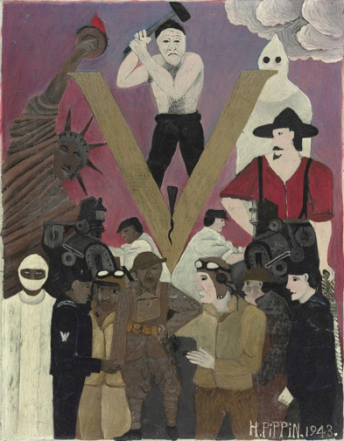

Mr. Prejudice, 1943.
Oil on canvas.
Philadelphia Museum of Art
Gift of Dr. and Mrs. Matthew T. Moore, 1984.108.1.

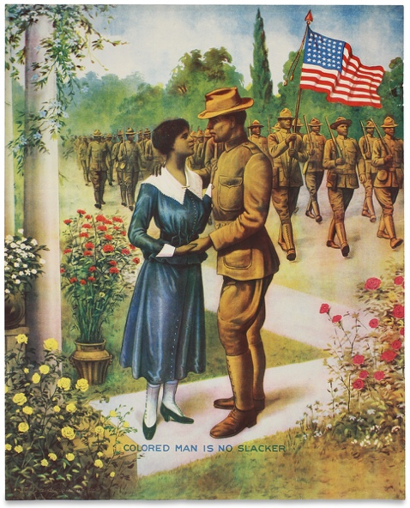
Edward George Renesch
Colored Man Is No Slacker, 1918.
Color lithograph. The Trout Gallery
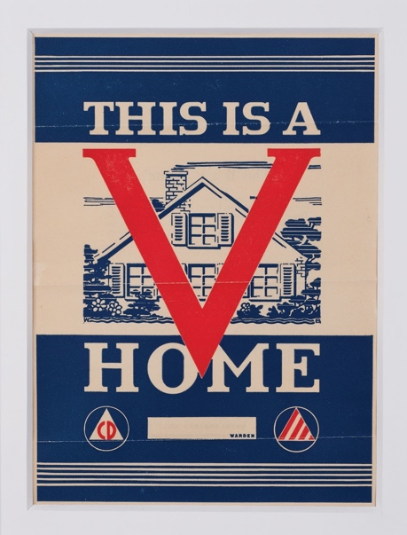
United States Printing Office
This is a V Home, 1942. Offset-lithograph.
The Trout Gallery.

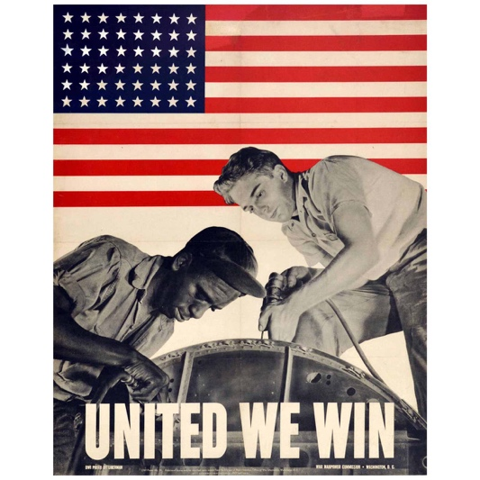
Alexander Liberman
United We Win, 1943.
Offset-lithograph.
The Trout Gallery

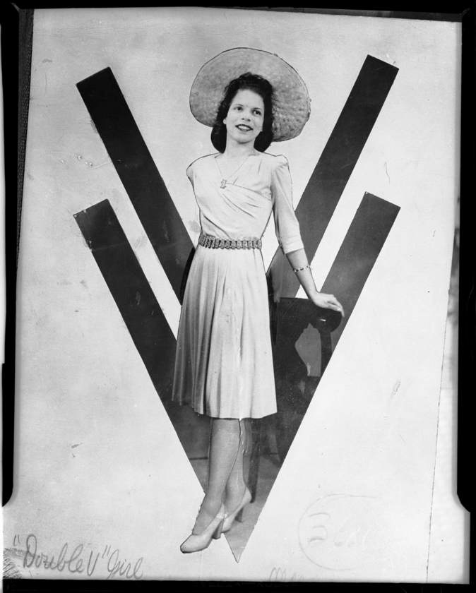

Charles “Teenie” Harris
“Double V Girl”, c. 1935–1945.
Modern print from vintage negative from the Carnegie Museum of Art.

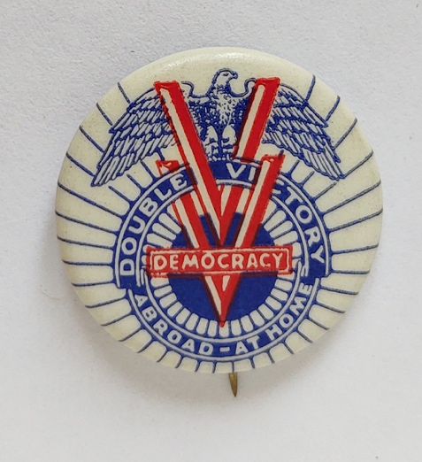

Double Victory / Democracy / Abroad / At Home, 1942.
Celluloid pin.
The Trout Gallery.

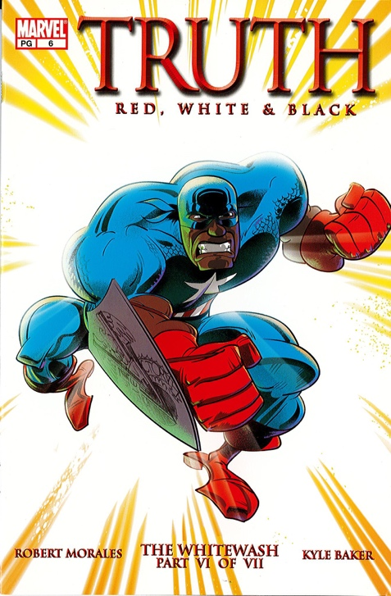

Robert Morales and Kyle Baker
Truth: Red, White & Black. The Whiewash: Part VI
Marvel Comics: New York, January 2003. Private Collection

